**Software Engineering Assignment**

**MODULE:[SDLC]**

* **What is software? What is software engineering?**
* Software is a set of instructions ,data or programs used to operate computers and execute specific taks . Software is a genric trem used to refer to applications ,scripts and programs that run on a device
* These software program are designed to run a computer application program and hardware .
* It is type of software application that help in the aautomation of the task based on the user input.
* that is five type of application software application software , system software, driver software ,middleware software ,programming software.
* Application software is the most common type of software . system software corrdinates the acitivity and function of the hardware and software Driver software also known as device driver.
* Explain types of software

1. System Software
2. Application Software
3. Driver software
4. Middleware
5. Programming Software

1. System Software : computer cannot run without system software use to run system and written in low lavel language . The os is the best example of system software . it corrdinate the activity to hardware and software.
2. Application software : application can be self –contained and program witch is run the application for the uses. Application software is a computer package software pacakage that run function for user.
3. Driver software : also known as a device driver.

Device driver control the device and enabiling them to perform their specific tasks that software is often consider type of system software.

1. Middleware: the term middleware describe software that mediates between application remote work request from an application in a computer that has one kind of OS. For example middleware enables microsofts windows to talk to word.
2. Programming software : Programming software is a program or set of programs which helps the software develops by giving them inb creating , debugging and maintaining other programs and applications.

* What is SDLC? Explain each phase of SDL**C**
* Sdlc is a structure that imposed the software product that defined the process for planning analysis designing inplimantation testing and maintenance

**SDLC = SOFTWARE DEVELOPMENT LIFE CYCLE**

1. Requirement collection / Gathering
2. Analysis
3. Designing
4. Implimentation
5. Testing
6. Maintanance
7. Requirement collection- process of identifiying your project requirement from start to end . Requirments gathering is the process of understanding what you are trying to build and why you are building it.

2. Analysis – System analysis is there very important throughout any software development process as plays as it plays a signtificant determining factor in the success of of any software project in terms of usefulness and delivery within established constraints and based on how well it performed .

3. Designing- It design lay out of page or application .Software design is a mechanism to trtansform user requirements into some suitable form which helps the programmer in software coding and implementation .

4. Implementation- Translating the detailed requirements and design into system components.

5.Testing- is where the development team tests the software for erros and deficiencies. The testing process should ensure each unit of the software works well.

6.Maintenance – if tester finding a debug from implementation they retrun to the developer and then he resolving debug and implement code and then again send to the tester approv then it was given to user or customer

* What is DFD ? Create a DFD diagram on Flipkart
* DFD stand of “data flow diagram” it is also known as a “BUBBLE CHART”
* Through which we can represent the flow of data graphically on an linformantion system .
* By using DFD we can easily understand the overall functionally of the system because the diagram represents the incoming data flow outgoing data flow and stores data in a graphical.

* It describes how data is processed in a system in terms of input and output

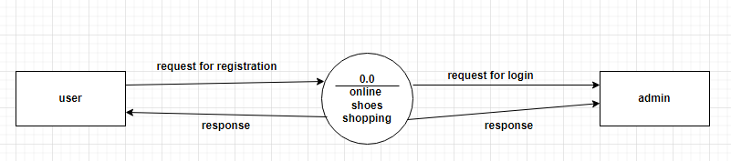

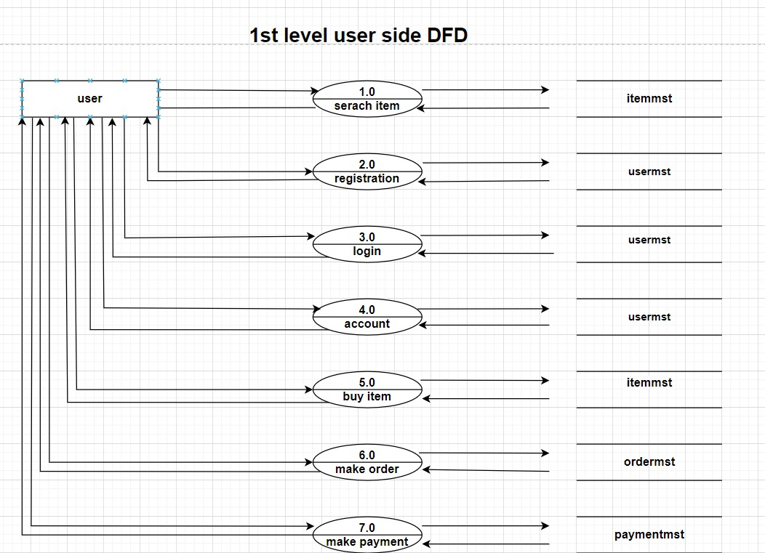

**What is flow chart ?Create a flowchart to make addition of two numbers**

* A flow chart is a picture of the separate steps of a process in sequential order. It is a genric tool that can be adapted for a wide variety of purpose and can be used to describe and various process,such as manufacturing process an administrative or service process,or a project plan.

{ Flow chart of addition of two numbers}

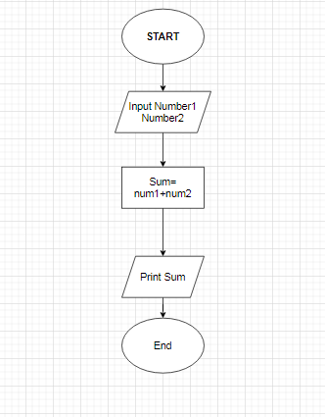

* What is use case diagram? Create a use-case on bill payment.
* A Use case is a written of how user will perform tasks on your website.it outlines,from auser’s point of view ,a system’s behavior as it respond to a request. Each use case is represented as a sequanace of simple steps beginning with a user’s goal and ending whwn that goal is fullfiled.

**\*ONLINE SHOPPING SYSTEM\***

